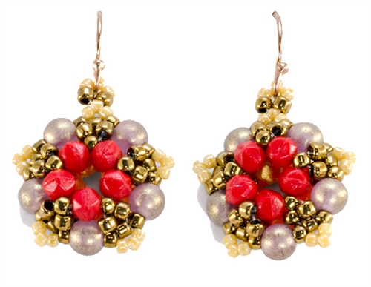
Little Five Points Earrings by Stephanie Goff
A great reversible design

SUPPLY LIST
10 - 4mm Round Beads (RB)
10 - 3mm English Cut Beads or 3mm round beads, Color A (ECa)
10 - 3mm English Cut Beads or 3mm round beads, Color B (ECb))
1 Gram 11/0 Seed Beads, Color A (S11a)
1 Gram 11/0 Seed Beads, Color B (S11b)
1 Gram 11/0 Seed Beads, Color (S11c)
1 Gram 15/0 Seed Beads (S15)
Bead Thread of Choice
2 Earwires
2 Jump Rings

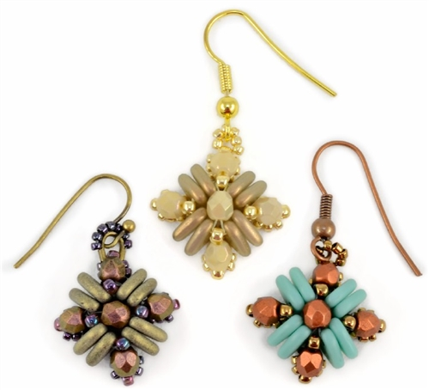
Teresa Earrings by Carole Ohl
SUPPLY LIST
16- CzechMates™ Triangles (TR)
10- 4mm Fire-Polished Beads (FP)
24 -11/0 Seed Beads (SB11)
76- 15/0 Seed Beads (SB15)
2 Earring Findings
Thread of Choice

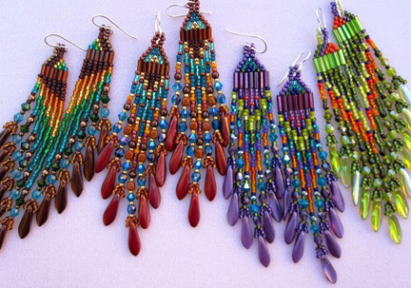

Supplies:

Bugle beads

11/0 beads or Delica/Treasures in two or three colors.

Daggers beads

Fire polish beads

Earwires

Fireline is best because of the sharp edges on the bugle beads.

